IAM ROLE Configurations:

**Make sure all these Permission Policies are in Place before you execute the Agentic Application**

**AmazonBedrockExecutionRoleForAgents_CEKZTX0JZCN**

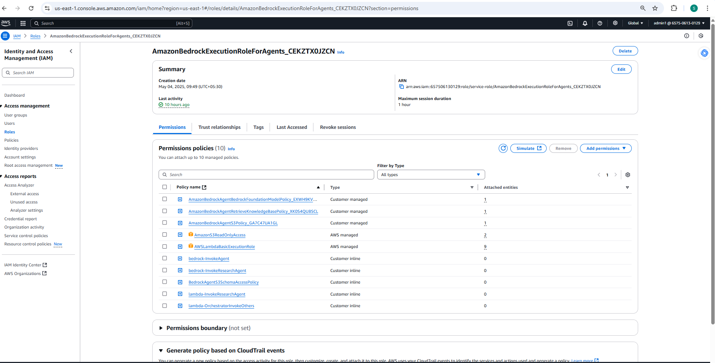

[AmazonBedrockAgentBedrockFoundationModelPolicy_EXWH9KVTKH4](https://us-east-1.console.aws.amazon.com/iam/home?region=us-east-1#/policies/details/arn%3Aaws%3Aiam%3A%3A657506130129%3Apolicy%2Fservice-role%2FAmazonBedrockAgentBedrockFoundationModelPolicy_EXWH9KVTKH4)

{

"Version": "2012-10-17",

"Statement": [

{

"Sid": "AmazonBedrockAgentBedrockFoundationModelPolicyProd",

"Effect": "Allow",

"Action": [

"bedrock:InvokeModel",

"bedrock:InvokeModelWithResponseStream"

],

"Resource": [

"arn:aws:bedrock:us-east-1::foundation-model/anthropic.claude-3-5-sonnet-20240620-v1:0"

]

}

]

}

[AmazonBedrockAgentRetrieveKnowledgeBasePolicy_XK0S4QU8SCL](https://us-east-1.console.aws.amazon.com/iam/home?region=us-east-1#/policies/details/arn%3Aaws%3Aiam%3A%3A657506130129%3Apolicy%2Fservice-role%2FAmazonBedrockAgentRetrieveKnowledgeBasePolicy_XK0S4QU8SCL)

{

"Version": "2012-10-17",

"Statement": [

{

"Sid": "AmazonBedrockAgentRetrieveKnowledgeBasePolicyProd",

"Effect": "Allow",

"Action": [

"bedrock:Retrieve"

],

"Resource": [

"arn:aws:bedrock:us-east-1:657506130129:knowledge-base/D4EMYQBLYR"

]

}

]

}

[AmazonBedrockAgentS3Policy_GA7C47UA1GL](https://us-east-1.console.aws.amazon.com/iam/home?region=us-east-1#/policies/details/arn%3Aaws%3Aiam%3A%3A657506130129%3Apolicy%2Fservice-role%2FAmazonBedrockAgentS3Policy_GA7C47UA1GL)

{

"Version": "2012-10-17",

"Statement": [

{

"Sid": "AmazonBedrockAgentS3PolicyProd",

"Effect": "Allow",

"Action": [

"s3:GetObject"

],

"Resource": [

"arn:aws:s3:::bedrock-rag-documents-979/documents/planner-api.yaml",

"arn:aws:s3:::bedrock-rag-documents-979/schemas/research-api.yaml",

"arn:aws:s3:::bedrock-rag-documents-979/documents/research-api.yaml",

"arn:aws:s3:::bedrock-rag-documents-979/schemas/planner-api.yaml"

],

"Condition": {

"StringEquals": {

"aws:ResourceAccount": "657506130129"

}

}

}

]

}

[bedrock-InvokeAgent](https://us-east-1.console.aws.amazon.com/iam/home?region=us-east-1#/roles/details/AmazonBedrockExecutionRoleForAgents_CEKZTX0JZCN/editPolicy/bedrock-InvokeAgent?step=addPermissions)

{

"Version": "2012-10-17",

"Statement": [

{

"Effect": "Allow",

"Action": "bedrock:InvokeAgent",

"Resource": [

"arn:aws:bedrock:us-east-1:657506130129:agent-alias/ZS3YXM3A0N/ACDHJUYEAX",

"arn:aws:bedrock:us-east-1:657506130129:agent-alias/2JDO8L2G4T/6FPKPA0NOD",

"arn:aws:bedrock:us-east-1:657506130129:agent-alias/WLKVRMVDGB/MISMIVZ7LP",

"arn:aws:bedrock:us-east-1:657506130129:agent-alias/VK2FQNLC2Y/RWLUPYAAV3"

]

}

]

}

[bedrock-InvokeResearchAgent](https://us-east-1.console.aws.amazon.com/iam/home?region=us-east-1#/roles/details/AmazonBedrockExecutionRoleForAgents_CEKZTX0JZCN/editPolicy/bedrock-InvokeResearchAgent?step=addPermissions)

{

"Version": "2012-10-17",

"Statement": [

{

"Effect": "Allow",

"Action": "bedrock:InvokeAgent",

"Resource": "arn:aws:bedrock:us-east-1:657506130129:agent-alias/2JDO8L2G4T/6FPKPA0NOD"

}

]

}

[BedrockAgentS3SchemaAccessPolicy](https://us-east-1.console.aws.amazon.com/iam/home?region=us-east-1#/roles/details/AmazonBedrockExecutionRoleForAgents_CEKZTX0JZCN/editPolicy/BedrockAgentS3SchemaAccessPolicy?step=addPermissions)

{

"Version": "2012-10-17",

"Statement": [

{

"Effect": "Allow",

"Action": "s3:GetObject",

"Resource": "arn:aws:s3:::bedrock-rag-documents-979/*"

}

]

}

[lambda-InvokeResearchAgent](https://us-east-1.console.aws.amazon.com/iam/home?region=us-east-1#/roles/details/AmazonBedrockExecutionRoleForAgents_CEKZTX0JZCN/editPolicy/lambda-InvokeResearchAgent?step=addPermissions)

{

"Version": "2012-10-17",

"Statement": [

{

"Effect": "Allow",

"Action": "lambda:InvokeFunction",

"Resource": [

"arn:aws:lambda:us-east-1:657506130129:function:InvokeResearchAgent",

"arn:aws:lambda:us-east-1:657506130129:function:InvokeResearchAgent:*"

]

}

]

}

[BedrockAgentS3SchemaAccessPolicy](https://us-east-1.console.aws.amazon.com/iam/home?region=us-east-1#/roles/details/AmazonBedrockExecutionRoleForAgents_CEKZTX0JZCN/editPolicy/BedrockAgentS3SchemaAccessPolicy?step=addPermissions)

{

"Version": "2012-10-17",

"Statement": [

{

"Effect": "Allow",

"Action": "s3:GetObject",

"Resource": "arn:aws:s3:::bedrock-rag-documents-979/*"

}

]

}

[lambda-InvokeResearchAgent](https://us-east-1.console.aws.amazon.com/iam/home?region=us-east-1#/roles/details/AmazonBedrockExecutionRoleForAgents_CEKZTX0JZCN/editPolicy/lambda-InvokeResearchAgent?step=addPermissions)

{

"Version": "2012-10-17",

"Statement": [

{

"Effect": "Allow",

"Action": "lambda:InvokeFunction",

"Resource": [

"arn:aws:lambda:us-east-1:657506130129:function:InvokeResearchAgent",

"arn:aws:lambda:us-east-1:657506130129:function:InvokeResearchAgent:*"

]

}

]

}

[lambda-OrchestratorInvokeOthers](https://us-east-1.console.aws.amazon.com/iam/home?region=us-east-1#/roles/details/AmazonBedrockExecutionRoleForAgents_CEKZTX0JZCN/editPolicy/lambda-OrchestratorInvokeOthers?step=addPermissions)

{

"Version": "2012-10-17",

"Statement": [

{

"Effect": "Allow",

"Action": "lambda:InvokeFunction",

"Resource": [

"arn:aws:lambda:us-east-1:657506130129:function:InvokePlannerAgent",

"arn:aws:lambda:us-east-1:657506130129:function:InvokeSummarizerAgent",

"arn:aws:lambda:us-east-1:657506130129:function:InvokeCritiqueAgent"

]

}

]

}

Trust relationships

{

"Version": "2012-10-17",

"Statement": [

{

"Sid": "AmazonBedrockAgentBedrockFoundationModelPolicyProd",

"Effect": "Allow",

"Principal": {

"Service": "bedrock.amazonaws.com"

},

"Action": "sts:AssumeRole",

"Condition": {

"StringEquals": {

"aws:SourceAccount": "657506130129"

},

"ArnLike": {

"aws:SourceArn": "arn:aws:bedrock:us-east-1:657506130129:agent/*"

}

}

},

{

"Sid": "AllowLambdaAssumeRole",

"Effect": "Allow",

"Principal": {

"Service": "lambda.amazonaws.com"

},

"Action": "sts:AssumeRole"

}

]

}